Adam Gincel

Sept 8 2016

Assignment 1

*I pledge my honor that I have abided by the Stevens Honor System.*

1)

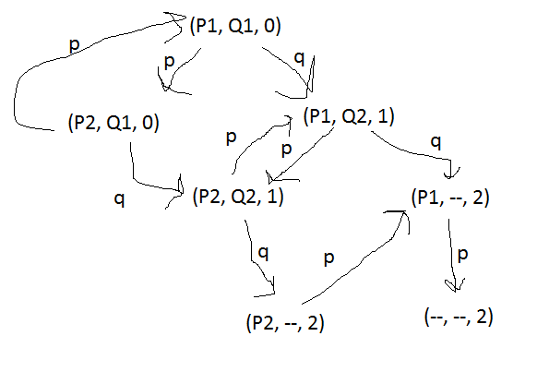

2) a) 012: (P1, Q1, 0) -> (P2, Q1, 0) -> (P1, Q1, 0) -> (P1, Q2, 1) -> (P2, Q2, 1) -> (P1, Q2, 1) -> (P2, Q2, 1) -> (P2, --, 2) -> (P1, --, 2) -> (--, --, 2)

b) 002: (P1, Q1, 0) -> (P2, Q1, 0) -> (P1, Q1, 0) -> (P2, Q1, 0) -> (P1, Q1, 0) -> (P1, Q2, 1) -> (P2, Q2, 1) -> (P2, --, 2) -> (P1, --, 2) -> (--, --, 2)

c) 02: (P1, Q1, 0) -> (P2, Q1, 0) -> (P1, Q1, 0) -> (P1, Q2, 1) -> (P2, Q2, 1) -> (P2, --, 2) -> (P1, --, 2) -> (--, --, 2)

3) Not necessarily; it is possible for Q to increment N to 2, and then have P check the condition, and thus terminate, without ever printing n = 2.

4) 2 can appear at most one time in the output; after printing 2, P will cycle back and check if n < 2, which has to be false.

5) 1 can appear infinitely many times in this output; given infinite execution time once N is set to 1, thread P will simply print 1 unendingly until Q is given time.

6) 0 can also appear infinitely many times in this output. If Q is never given any time at all, n will stay at 0 and thread P will print 0s forever.

7) Conversely to number 6, if Q is given execution time before P and runs entirely before P ever runs, it is possible that n will == 2 before P ever makes its first comparison and enters its while loop. Therefore, it is possible that this program can output no numbers at all – the shortest sequence is empty.